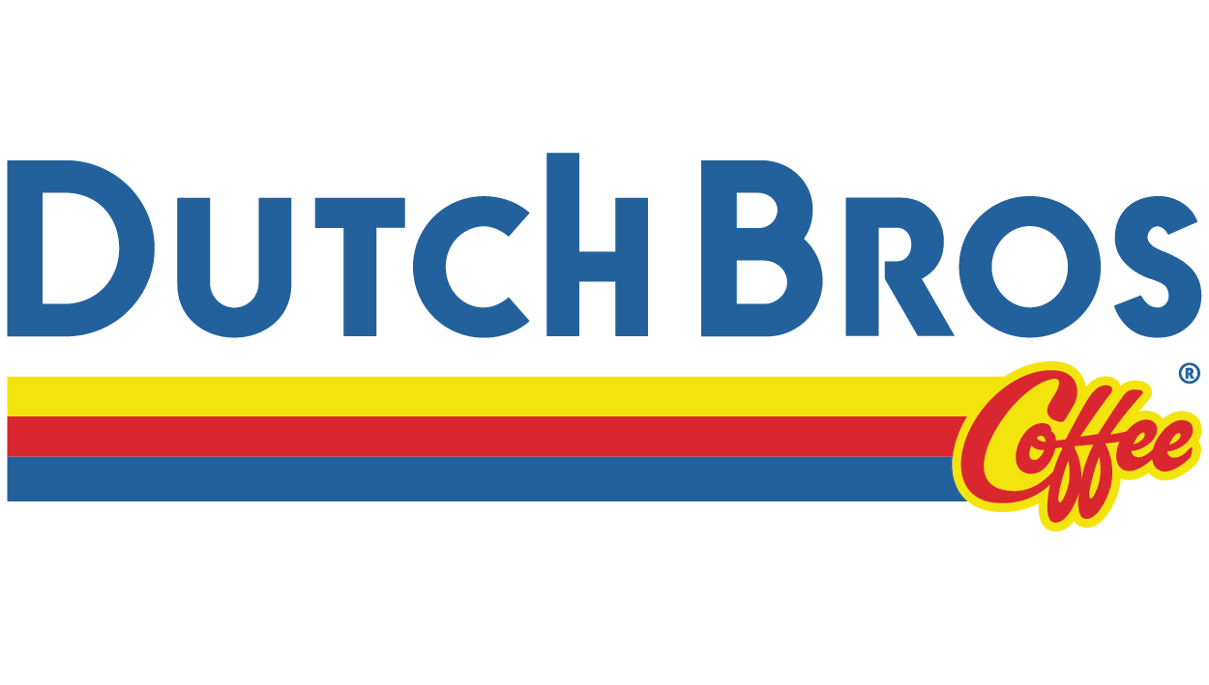

Usability Testing Materials

- Jennifer Tabana

- Justin Gaeta
- Laurie Wandle
- Suzanie Pham

Pre-test Questionnaire
https://docs.google.com/spreadsheets/d/e/2PACX-1vTXRuM--hSAsHAP8RD36BQnHI2lZI0LBhn10ck97o0dgSIuoleiz7qQ0tImbVG7lEmxUYz4j_ZtqCs2/pubhtml

What is your gender?

What is your age?

Are you a fan of coffee? If yes, do you prefer Dutch Bros over other brands?

How often do you get coffee or similar beverages?

How knowledgeable are you of the Dutch Bros menu?

Are you familiar with the Dutch Bros app?

What are the reasons why you visit the Dutch Bros website?

How often do you visit the site?

How much time do you spend on the Dutch Bros website?

What features do you use the most on the website?

Scenarios / Tasks

- You just arrived in Seattle, Washington for a work conference. It’s 7am and you need/want a Dutch Bros featured coffee drink.

- Find a Dutch Bros location near you.
- Find a Dutch Bros featured coffee drink.

2. You are headed to work and before starting your early commute,
you decide to go through the drive through and get yourself an
iced coffee and snack but are unsure of the options.

- Find your favorite coffee drink.
- Find food options.

3. You forgot your wallet and only have $5 dollars for a drink. You decide to download the Dutch Bros app to look for options.

a) Download the Dutch Bro app.
b) Find drink menu prices.

4. You are craving a Dutch Bro Cold Brew and you have enough Dutch Bro rewards for a free medium drink.

a). Navigate to the Dutch Bro rewards program on the app.
b). Locate terms and conditions on the app.

Post-test Questionnaire

- How would you rate your experience with using the dutch bros location function on the website?

Very easy / Easy / Neutral / Difficult / Very difficult

Why?

- Based on the website layout, how would you rate your ability to find featured drinks?
Very easy / Easy / Neutral / Difficult / Very difficult

- How would you rate your experience with locating the full menu options?

Very easy / Easy / Neutral / Difficult / Very difficult

Why?

- How would you rate your experience searching for your favorite Dutch Bros drink?

Very easy / Easy / Neutral / Difficult / Very difficult

- How would you describe your overall experience with the navigation on the website?

Very easy / Easy / Neutral / Difficult / Very difficult

Why?

Observation Sheet

Task 1 : Find a Dutch bros location near you.
Task completion: Pass/Fail
Completed when | User enters the ‘See Details’ screen of their selected location
Expected Time on Task | Less than 1 minute
Actual time on Task
Expected Path | Home > Location Button > Search by location / auto-fill > select ‘See Details’
Actual Path
Quotes

Observations and comments:

Task 2 : Find Featured coffee drink on the website
Task completion: Pass/Fail
Completed when | User either finds ‘Featured Drinks’ page or location on main menu
Expected Time on Task | Less than 1 minute
Actual time on Task
Expected Path | Opt 1. Home > Click on “tell me more” button  Opt 2. Home > Click on “see full menu” button
Actual Path
Quotes

Observations and comments:

Task 3 : Find your favorite coffee drink.
Task completion: Pass/Fail
Completed when | Completed when user reaches their desired drink
Expected Time on Task | Less than 1 minute
Actual time on Task
Expected Path | Home > Drink Menu button
Actual Path
Quotes

Observations and comments:

Task 4 : Find food options on the website.
Task completion: Pass/Fail
Completed when | User lands on food options page
Expected Time on Task | Less than 1 minute
Actual time on Task
Expected Path | Home > Drink Menu button > ‘It’s all goodies’ button
Actual Path
Quotes

Observations and comments:

Task 5 : Download the Dutch Bros app from their website.
Task completion: Pass/Fail
Completed when | When user successfully downloads the app
Expected Time on Task | Less than 1 minute
Actual time on Task
Expected Path | Home > Navigate to footer > Click download CTA button
Actual Path
Quotes

Observations and comments:

Task 6 : Find drink menu prices on the website.

*No purchase required to complete task*
Task completion: Pass/Fail
Completed when | User reaches the menu item.
Expected Time on Task
Actual time on Task | Less than 1 minute
Expected Path | Home> Navigation>Full Menu>Menu Item
Actual Path
Quotes

Observations and comments:

Task 7 : Claim free medium drink reward on Dutch Bros app.

Task completion: Pass/Fail
Completed when | User redeems perk on app
Expected Time on Task | Approximately 1 minute
Actual time on Task
Expected Path | Open app > scroll to redemption options > click on appropriate option
Actual Path
Quotes

Observations and comments:

Task 8 : Locate terms and service on the website.
Task completion: Pass/Fail
Completed when | User successfully opens the terms and service on the website.
Expected Time on Task | Less than 1 minute
Actual time on Task
Expected Path | Home > Scroll to footer > User clicks ToS link
Actual Path
Quotes

Observations and comments:

